David Wu

Paper Tower Tutourial

1.) Cut out 8 strips that are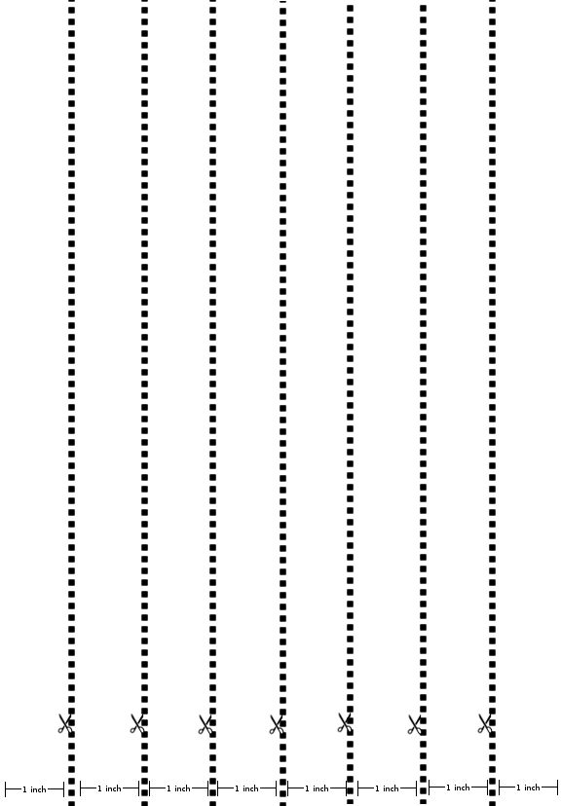

1”x 11

2.) Roll 6 of the strips into 1/4”x11” tubes.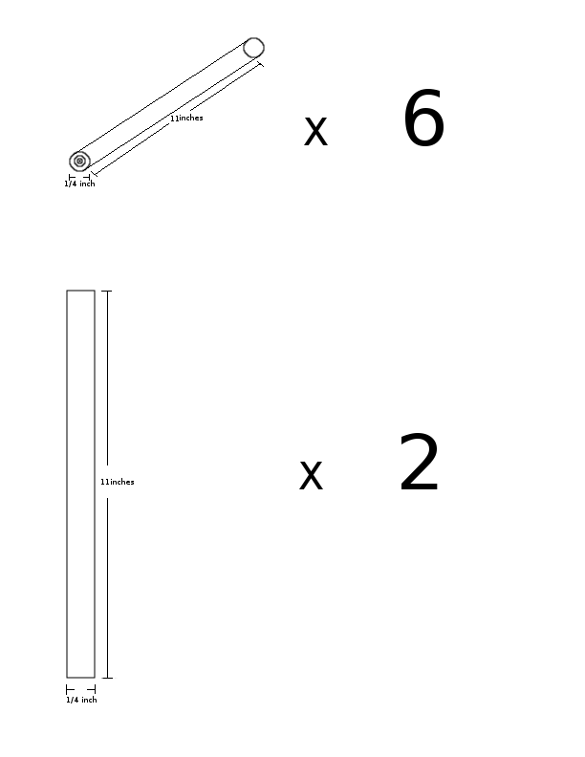

3.) Fold 2 of the strips in half 2 times, to get some 1/4”x11” flat strips of paper.

4.) Make 2 separate rings with the strips of paper. Tape ends together with 2/5 inch of tape.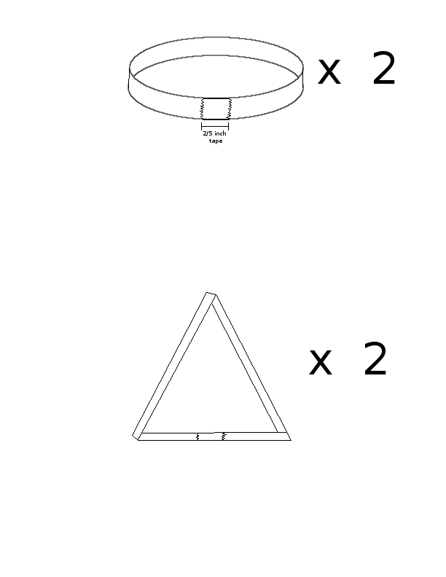

5.) Take your 2 rings and pinch the corners to form 2 separate equilateral triangles.

6.) Pair up all the tubes and tape them together with 2/5 inch of tape.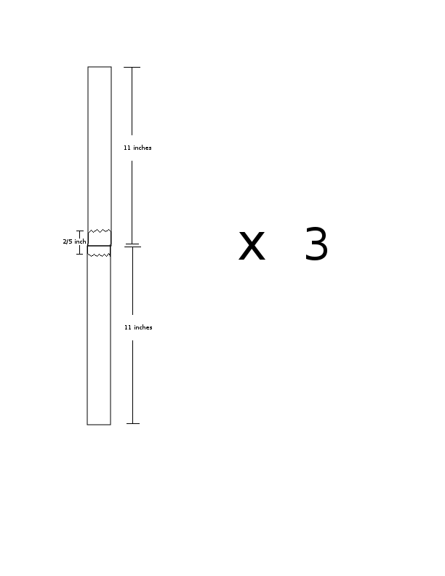

7.) Cut 1 inch in the middle of both ends of all the tubes.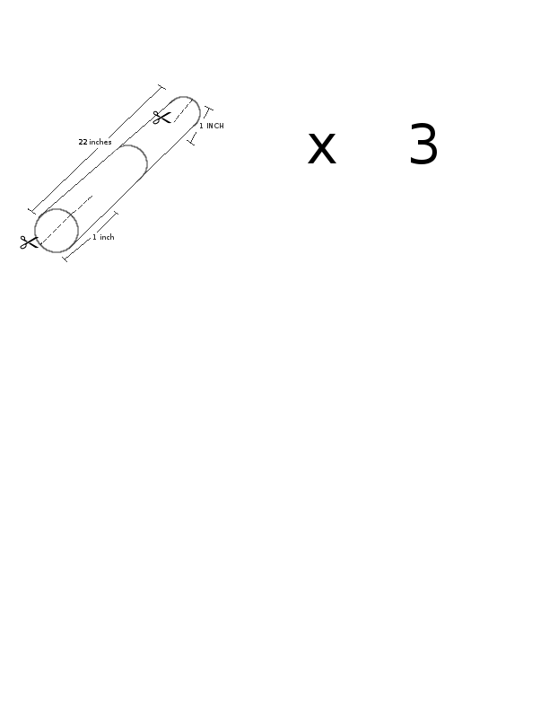

8.) At each corners of both the triangles you made, slide in a tube. Your structure should look like the figure 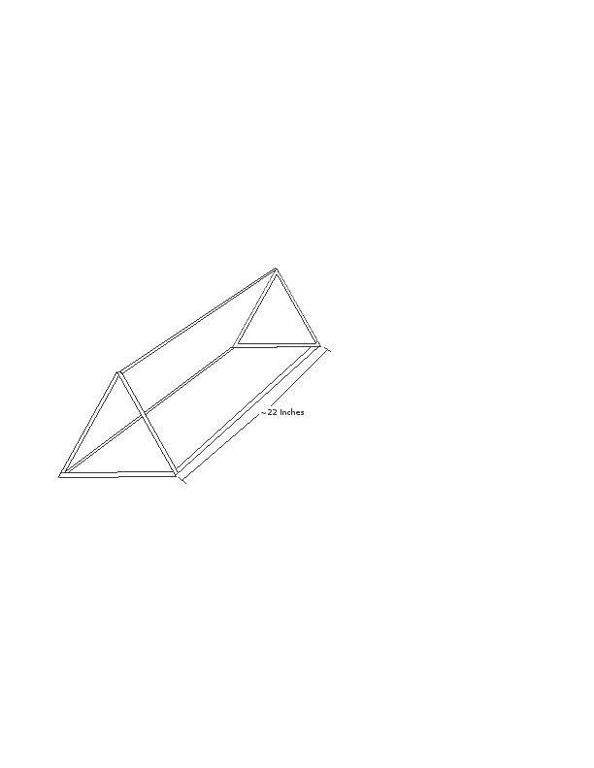below.